Title: |  | (English)
 |  | (中文)
[Suggestions: No more than 16 words.]
Forename Surname¹, Forename Surname^{1,2}, Forename Surname³
中文姓名¹、中文姓名^{1,2}、中文姓名³

¹ Department, Institution, City, Country.
¹部門，機構，城市，國家。
² Department, Institution, City, Country.
²部門，機構，城市，國家。
³ Department, Institution, City, Country.
³部門，機構，城市，國家。

Correspondence to: Prof./Dr. Forename Surname, Department, Institution, Detailed Address, City Postcode, Country. Phone number, Fax number, E-mail: xxxx@xxxx.xxx

Running title: |  | (English)
 |  | (中文)

Original Article /原著
ABSTRACT [Suggestions: No more than 250 words. No citations. Define abbreviations at their first mention.]
Objective: The purpose of this study, i.e., the reason why authors write this manuscript.
Methods: The detailed methods applied to this study, including description of patients/subjects, materials, software, research methods, study object, etc.
Results: The main findings of this study, including conclusive description, analysis, and comparison with other related research results, etc.
Conclusion: We suggest that authors may highlight its significance, emphasize the value of this study and state expectation on future studies that may need to be carried out.
Key words: [Please suggest up to 5 keywords which can be used for describing the content of the manuscript and will enable the full text of the manuscript to be searchable online.]
摘要 [建議: 勿超過400字]
目的：本研究的目的，即作者撰寫此手稿的原因。
方法：使用於本研究的詳細方法，包括患者/受試者、材料、軟體、研究方法、研究對像等的描述。
結果：本研究的主要發現，包括結論性描述，分析以及與其他相關研究結果的比較等。
結論：建議作者可以強調其重要性，強調本研究的價值，並指出對可能需要進行的未來研究的期望。
關鍵詞：[至多5個，可供描述投稿文章重點內容與網路檢索全文之用]
INTRODUCTION / 前言
本節重點在陳述研究的目的，概述或總結了與該研究有關的先前發現和進展，並指出了本文在該研究領域中的意義。
MATERIALS ＆ METHODS / 材料與方法
建議作者可以設置標題，並提供有關您如何進行研究以及所做工作的所有詳細資訊。本節請詳盡的陳述包含研究執行期間、研究對象的選取、研究材料、相關軟硬體資源、研究設計、統計方法等的描述。
RESULTS / 結果
本節請陳述您的研究的主要發現。內容可能包含推論性的描述、分析以及與其他相關研究結果的比較等。作者可以在本節中設置標題，以區分不同分析比較的結果。
DISCUSSION / 討論
在本節中，作者應討論該研究的重要性，比較該研究與相關文獻結果之異同或爭議之處，強調其價值和未來可能需要進一步探究分析之期望
CONCLUSION /結論
本節論述建議著重研究中的關鍵發現、研究的優勢和潛在限制以及未來的研究方向等。

TABLES
Examples are shown below:
Table 1. This is a table caption. A summary description should be written here.
[The words size please set 12pt]
Variables | stratification | OP time |  |  |  |  |  | P value
 |  | ≦30 min |  | 31 to 59 min |  | ≧60 min
 |  | N=103 |  | N=67 |  | N=36
Age | (mean±sd) | 50.1±13.1 |  | 52.8±14.4 |  | 60.9±13.3 |  | <0.001*
Sex (n, %) | Male | 42 | 40.8% | 25 | 37.3% | 22 | 61.1% | 0.052
 | Female | 61 | 59.2% | 42 | 62.7% | 14 | 38.9%
Grade (n, %) | I | 66 | 68.0% | 30 | 46.2% | 5 | 13.9%
 | II | 31 | 32.0% | 33 | 50.8% | 28 | 77.8%
 | III | 0 | 0 | 2 | 3.1% | 3 | 8.3%
Score of
GB appearance | (mean±sd) | 0.8±1.0 |  | 4.7±2.3 |  | 2.1±2.3 |  | <0.001*
Calot’s Triangle | (mean±sd) | 0.9±1.0 |  | 2.8±2.4 |  | 5.0±2.2 |  | <0.001*
Liver Bed | (mean±sd) | 0.7±0.9 |  | 2.3±2.1 |  | 4.5±2.3 |  | <0.001*
Total | (mean±sd) | 2.4±2.7 |  | 7.8±6.5 |  | 15.3±6.6 |  | <0.001*
* p<0.05 [This part is footer. The words size please set 10pt]
FIGURES
Examples are shown below:

Figure 1. A summary description of this figure should be written here
[The words size please set 12pt]
REFERENCES (參考文獻)
Authors should cite references in sequence throughout the manuscript.
Examples of references are shown below:
Journal:
    - Litynski GS. Profiles in laparoscopy: Mouret, Dubois, and Perissat: the laparoscopic breakthrough in Europe (1987-1988). JSLS. 1999;3:163-7.
    - Gupta V, Jain G. Safe laparoscopic cholecystectomy: Adoption of universal culture of safety in cholecystectomy. World J Gastrointest Surg. 2019;11:62-84.
    - Tseng CS, Tang KS, Lo HW, et al. UDP-glucuronosyltransferase 1A7 genetic polymorphisms are associated with hepatocellular carcinoma risk and onset age. Am J Gastroenterol. 2005;100:1758-63.
Books:
    - Ringsven MK, Bond D. Gerontology and leadership skills for nurses. 2nd ed. Albany (NY): Delmar Publishers; 1996.
Book chapters:
    - Bernard A. Fundamentals of biostatistics. In: Kugushev A, Purrington L, editors. Regression and correlation methods. 4th ed. USA: Duxbury Press; 1994. pp. 443-550.
Internet source data for official or academic institutions:
    - Statistical Analysis of Death Causes in the Statistics Department of the Ministry of Health and Welfare in 2017. Available from: http://dep.mohw.gov.tw/DOS/ lp-3352-113.html.

Review Article or Medical Column / 綜合論述 或醫學專欄
ABSTRACT [Suggestions: No more than 250 words. No citations. Define abbreviations at their first mention.]
Abstract is a brief summary of an article, which helps the readers quickly ascertain the paper's main content.
Key words: [Please suggest up to 5 keywords which can be used for describing the content of the manuscript and will enable the full text of the manuscript to be searchable online.]
摘要[建議: 勿超過400字]
簡要的陳述本文稿的重點，藉以協助讀者快速掌握本論文的主要論述內容。
關鍵詞：[關鍵詞至多5個，可供描述投稿文章重點內容與網路檢索全文之用]
INTRODUCTION / 前言
本節重點在陳述研究的目的，概述或總結了與該研究有關的先前發現和進展，並指出了本文在該研究領域中的意義。
LEVEL 1 HEADING / 標題一
[e.g., MAIN TEXT / 本文]
在本節中，作者應詳細描述評論相關文獻，其內容可能包含(1)特定領域中代表性研究的摘要、(2)過去研究的方法、結果與其優缺點、(3)作者對該相關研究主題的觀點等。我們建議作者可以依論述重點，分別設置數節標題，再於各節內分點論述，以區分不同的情況，例如：
- Level 2 heading
- Level 3 heading
CONCLUSION / 結論
作者應總結研究的主要結論。內容可能包含主要發現的摘要、關於研究的優勢和局限性的陳述、或該工作對未來研究的影響等。
TABLES
Examples are shown below:
Table 1. This is a table caption. A summary description should be written here
[The words size please set 12pt]
Variables  NLR | β | Hazard ratio | 95% CI of HR |  | P value
 |  | (HR) | Lower | Upper
Liver
≦1.62(Ref.) |  | 1.000
1.63-2.57 | 0.038 | 0.963 | 0.650 | 1.430 | 0.851
≧2.58 | 0.405 | 1.500 | 1.060 | 2.114 | 0.021*
Colorectum
≦1.62(Ref.) |  | 1.000
1.63-2.57 | 0.664 | 1.943 | 0.849 | 4.449 | 0.116
≧2.58 | 0.872 | 2.393 | 1.111 | 5.151 | 0.026*
Breast
≦1.62(Ref.) |  | 1.000
1.63-2.57 | 0.638 | 1.893 | 0.870 | 4.119 | 0.108
≧2.58 | 0.978 | 2.660 | 1.247 | 5.675 | 0.011*
Lung
≦1.62(Ref.) |  | 1.000
1.63-2.57 | 0.663 | 1.940 | 1.237 | 3.044 | 0.004*
≧2.58 | 0.965 | 2.625 | 1.763 | 3.909 | 0.001*
The confounding factors were adjusted including age, sex, stage and surgical resection status. *p<0.05.
[This part is footer. The words size please set 10pt]

FIGURES
Examples are shown below:
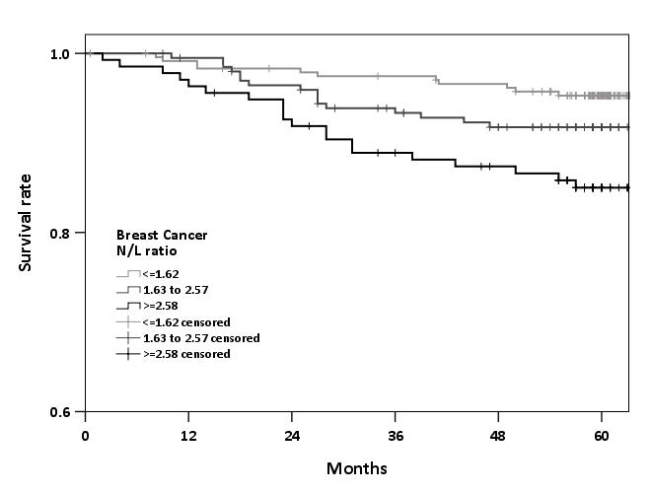
Figure 1. A summary description of this figure should be written here
[The words size please set 12pt]
REFERENCES (參考文獻)
Authors should cite references in sequence throughout the manuscript.
Examples of references are shown below:
Journal:
- Litynski GS. Profiles in laparoscopy: Mouret, Dubois, and Perissat: the laparoscopic breakthrough in Europe (1987-1988). JSLS. 1999;3:163-7.
- Gupta V, Jain G. Safe laparoscopic cholecystectomy: Adoption of universal culture of safety in cholecystectomy. World J Gastrointest Surg. 2019;11:62-84.
- Tseng CS, Tang KS, Lo HW, et al. UDP-glucuronosyltransferase 1A7 genetic polymorphisms are associated with hepatocellular carcinoma risk and onset age. Am J Gastroenterol. 2005;100:1758-63.
Books:
- Ringsven MK, Bond D. Gerontology and leadership skills for nurses. 2nd ed. Albany (NY): Delmar Publishers; 1996.
Book chapters:
- Bernard A. Fundamentals of biostatistics. In: Kugushev A, Purrington L, editors. Regression and correlation methods. 4th ed. USA: Duxbury Press; 1994. pp. 443-550.
Internet source data for official or academic institutions:
- Statistical Analysis of Death Causes in the Statistics Department of the Ministry of Health and Welfare in 2017. Available from: http://dep.mohw.gov.tw/DOS/ lp-3352-113.html.

Case Report / 病例報告
ABSTRACT [Suggestions: No more than 150 words.]
This is a brief summary of an article, which helps the readers quickly ascertain the paper’s main content. In this part, authors may mention writing purpose, background, case presentation, conclusion, etc.
Key words: [Please suggest up to 5 keywords which can be used for describing the content of the manuscript and will enable the full text of the manuscript to be searchable online.]
摘要 [建議: 勿超過300字]
這是文稿內容的簡要陳述，可幫助讀者快速確定本文的主要內容。在這一部分中，作者可能會提及寫作的目的、背景、病例介紹、結論等內容。
關鍵詞：[關鍵詞至多5個，可供描述投稿文章重點內容與網路檢索全文之用]
INTRODUCTION / 前言
本節重點陳述了研究的背景，概述或總結了與該研究有關的先前發現和結果，且僅描述了病例信息並指出了撰寫本文的目的等。
CASE REPORT / 病例報告
在本節中，作者應盡可能詳細地描述每個病例，包括病例的背景、所涉及患者的詳盡臨床資訊、所應用的手術或治療方法，每個階段的結果以及後期分析等。
DISCUSSION / 討論
在這一部分中，作者應討論該研究的重要性，強調其價值和對可能需要進行的未來研究的狀態期望。
CONCLUSION / 結論
應強調包括關鍵發現的摘要、研究的優勢和局限性，該研究引起的爭議以及未來的研究方向等。
TABLES
Examples are shown below:
Table 1. This is a table caption. A summary description should be written here
[The words size please set 12pt]
Day | 1 | 2 | 3 | 4 | 5 | 6
Hct (%) | 44.9 | 38.5 | 39.1 | 36.9 | 36.9 | 36.5
Hb (g/dL) | 15.3 | 13.3 | 13.3 | 12.5 | 12.4 | 12.3
W.B.C(K/μL) | 14.26 | 8.28 | 8.20 | 7.12 | 6.34 | 8.57
Platelets (K/μL) | 192 | 141 | 136 | 134 | 144 | 183
INR | 1.04 | - | - | - | - | -
BUN (mg/dL) | 23 | 15 | - | - | - | 14
Creatinine (mg/dL) | 1.1 | 0.8 | 0.8 | - | 0.8 | 0.7
AST(U/L) | 1736 | 723 | - | - | - | -
ALT(U/L) | 830 | 542 | 387 | - | 199 | 234
LDH(U/L) | - | 959 | - | - | - | -
CK(U/L) | - | 7111 | 4677 | 2430 | 1486 | -
CK-MB(U/L) | - | 72 | - | - | - | -
Troponin I (ng/mL ) | - | 3.57 | 0.76 | 0.33 | 0.12 | -
Serum biochemistry in ICU from day 1 to day 6
[This part is footer. The words size please set 10pt]

FIGURES
Examples are shown below:
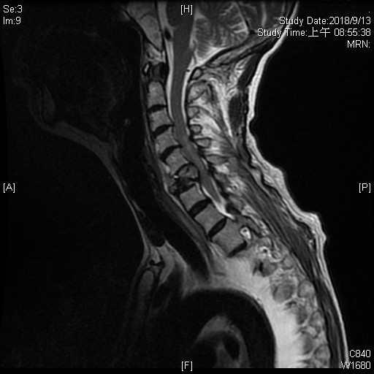
Figure 1. A summary description of this figure should be written here
[The words size please set 12pt]
REFERENCES (參考文獻)
Authors should cite references in sequence throughout the manuscript.
Examples of references are shown below:
Journal:
- Litynski GS. Profiles in laparoscopy: Mouret, Dubois, and Perissat: the laparoscopic breakthrough in Europe (1987-1988). JSLS. 1999;3:163-7.
- Gupta V, Jain G. Safe laparoscopic cholecystectomy: Adoption of universal culture of safety in cholecystectomy. World J Gastrointest Surg. 2019;11:62-84.
- Tseng CS, Tang KS, Lo HW, et al. UDP-glucuronosyltransferase 1A7 genetic polymorphisms are associated with hepatocellular carcinoma risk and onset age. Am J Gastroenterol. 2005;100:1758-63.
Books:
- Ringsven MK, Bond D. Gerontology and leadership skills for nurses. 2nd ed. Albany (NY): Delmar Publishers; 1996.
Book chapters:
- Bernard A. Fundamentals of biostatistics. In: Kugushev A, Purrington L, editors. Regression and correlation methods. 4th ed. USA: Duxbury Press; 1994. pp. 443-550.
Internet source data for official or academic institutions:
- Statistical Analysis of Death Causes in the Statistics Department of the Ministry of Health and Welfare in 2017. Available from: http://dep.mohw.gov.tw/DOS/ lp-3352-113.html.

